November | 2019

Snack Menu Milk served with snack

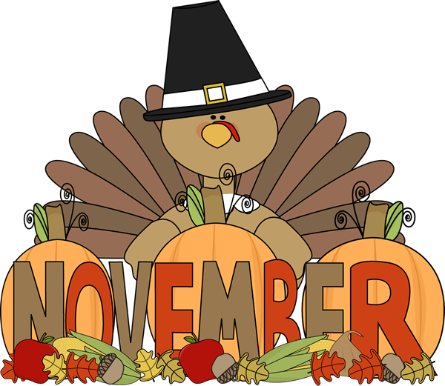
This Photo by Unknown Author is licensed under CC BY-NC-ND
Sunday | Monday | Tuesday | Wednesday | Thursday | Friday | Saturday
Menu subject to change |  |  |  |  | 1 | 2
This institution is an equal opportunity provider and employer |  |  |  |  | String Cheese
3 | 4 | 5 | 6 | 7 | 8 | 9
 | Pretzels w/ P.B. | Goldfish Crackers | Applesauce Cup | ½ Turkey & Cheese Sandwich | W.G. Ritz Cracker
10 | 11 | 12 | 13 | 14 | 15 | 16
 | Crunchy Cheetos | W.W. Sandwich Cracker W/ Cheese | Tropical Fruit Cup | Raisins | W.G Sandwich Cracker W/ P.B.
17 | 18 | 19 | 20 | 21 | 22 | 23
 | String Cheese | Banana | Goldfish Crackers | Pretzels | Strawberry Cup
24 | 25 | 26 | 27 | 28 | 29 | 30
 | W.G. Sandwich Cracker W/ Cheese | Mixed Berry Cup | Cheese and Crackers | No School | No School

